Syllabus
Binary Search- Introduction, Applications: Median of two sorted arrays, Find the fixed point in a given array, Find Smallest Common Element in All Rows, Longest Common Prefix, Koko Eating Bananas.
Greedy Method: General method – Applications –Minimum product subset of an array, Best Time to Buy and Sell Stock, Knapsack problem, Minimum cost spanning trees, Single source shortest path problem.
- Binary Search
Introduction:
- Given a sorted array arr[] of n elements, write a function to search a given element x in arr[].
- A simple approach is to do Linear Search.
- The time complexity of above algorithm is O(n). Another approach to perform the same task is using Binary Search.
- A binary search or half-interval search algorithm finds the position of a specified value (the input "key") within a sorted array.
- In each step, the algorithm compares the input key value with the key value of the middle element of the array.
- If the keys match, then a matching element has been found so its index, or position, is returned.
- Otherwise, if the sought key is less than the middle element's key, then the algorithm repeats its action on the sub-array to the left of the middle element or, if the input key is greater, on the sub-array to the right.
- If the remaining array to be searched is reduced to zero, then the key cannot be found in the array and a special "Not found" indication is returned.
- Every iteration eliminates half of the remaining possibilities. This makes binary searches very efficient - even for large collections.
- Binary search requires a sorted collection. Also, binary searching can only be applied to a collection that allows random access (indexing).
Worst case performance: O(log n)
Best case performance: O(1)
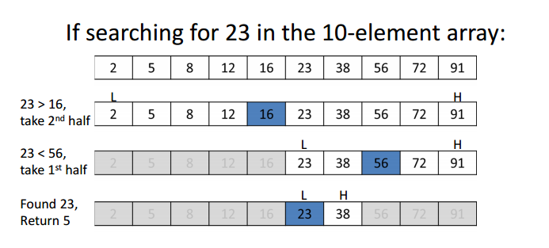
Working:
Binary Search Algorithm can be implemented in two ways which are discussed below.
- Recursive Method
- Iterative Method

1.Iterative Algorithm ( Divide and Conquer Technique)
// a is an array of size n, x is the key element to be searched.
Algorithm BinSearch(a, n, x)
{
low:=1; high:=n;
while( low ≤ high)
{
mid:=(low+high)/2;
if (x==a[mid])
{
return mid;
}
if( x< a[mid] ) then
high := mid-1;
else
low := mid+1;
}
return 0;
}

2. Recursive Algorithm ( Divide and Conquer Technique)

/*Given an array a [ low:high] of elements in increasing order,1≤low≤high,determine whether x is present, and if so, return j such that x=a[j]; else return 0.*/
Algorithm BinSrch (a, low, high, x)
{
if( low ==high ) then // If small(P)
{
if( x=a[low] ) then return low;
else return 0;
}
else
{
//Reduce p into a smaller subproblem.
mid:= (low+high)/2
if( x = a[mid] ) then
return mid;
else if ( x<a[mid] ) then
return BinSrch(a, low, mid-1, x);
else
return BinSrch(a, mid+1, high, x);
}
}

Time complexity of Binary Search
- If the time for diving the list is a constant, then the computing time for binary search is described by the recurrence relation.

T(n) = c₁ n=1, c1 is a constant
T(n/2) + c₂ n>1, c2 is a constant

T(n) = T(n/2) + c2
= T(n/4)+c2+c2
= T(n/8) +c2+c2+c2
…..
= T( n / 2^{k}) + c2+c2+c2+ ………..k times
= T(1)+ kc2
= c1+kc2 =c1+ logn*c2 = O(logn)

Successful searches:
best average worst
O(1) O(log n) O(log n)

Unsuccessful searches:
best average worst
O(log n) O(log n) O(log n)
Program for Iterative binary search:
BinarySearch_iterative.java

import java.util.*;
class BinarySearch_iterative
{
int binarySearch(int array[], int ele, int low, int high)
{
// Repeat until the pointers low and high meet each other
while (low <= high)
{
int mid = (low + high)/ 2;
if (array[mid] == ele)
return mid;
else if (array[mid] <ele)
low = mid + 1;
else
high = mid - 1;
}
return -1;
}

public static void main(String args[])
{
BinarySearch_iterativeob = new BinarySearch_iterative( );
Scanner sc = new Scanner(System.in);
System.out.println("Enter array size");
int n = sc.nextInt();
int array[]=new int[n];
System.out.println("Enter the elements of array ");
for(int i=0;i<n;i++)
{
array[i] = sc.nextInt();
}
// Sorting the array
Arrays.sort(array);
// Printing the array after sorting
System.out.println("Sorted array[]: "+ Arrays.toString(array));
System.out.println("Enter the search key");
int key = sc.nextInt();
int result = ob.binarySearch(array, key, 0, n - 1);
if (result == -1)
System.out.println("Element not found");
else
System.out.println("Element found at index " + result);
}
}

Program for Recursive binary search:
BinarySearch_recursive.java

import java.util.*;
class BinarySearch_recursive
{
int binarySearch(int array[], int x, int low, int high)
{
if (high >= low)
{
int mid = (high + low) / 2;
// If found at mid, then return it
if (array[mid] == x)
return mid;
// Search the left half
if (array[mid] > x)
return binarySearch (array, x, low, mid-1);
// Search the right half
return binarySearch(array, x, mid + 1, high);
}
return -1;
}

public static void main(String args[])
{
BinarySearch_recursiveob = new BinarySearch_recursive();
Scanner sc = new Scanner(System.in);
System.out.println("Enter array size");
int n = sc.nextInt();
int array[]=new int[n];
System.out.println("Enter the elements of array ");
for(int i=0;i<n; i++)
{
array[i] = sc.nextInt();
}

Arrays.sort(array);
// Printing the array after sorting
System.out.println("Sorted array[]: "+ Arrays.toString(array));
System.out.println("Enter the search key");
int key = sc.nextInt();
int result = ob.binarySearch(array, key, 0, n - 1);
if (result == -1)
System.out.println("Element not found");
else
System.out.println("Element found at index " + result);
}
}
Applications:
- Median of two sorted arrays.
- Find the fixed point in a given array.
- Find Smallest Common Element in All Rows.
- Longest Common Prefix.
- Koko Eating Bananas.

- Median of two sorted arrays.
- There are two sorted arrays A and B of sizes m and n respectively.
- Find the median of the two sorted arrays(The median of the array formed by merging both the arrays).
- Median: The middle element is found by ordering all elements in sorted order and picking out the one in the middle (or if there are two middle numbers, taking the mean of those two numbers).
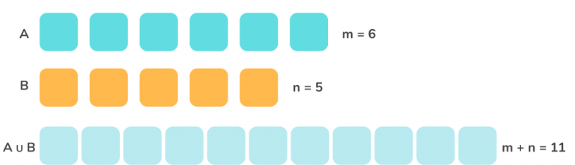
Examples:
Input: A[] = {1, 4, 5}, B[] = {2, 3}
Output: 3
Explanation:
Merging both the arrays and arranging in ascending:
[1, 2, 3, 4, 5]
Hence, the median is 3
Input: A[] = {1, 2, 3, 4}, B[] = {5, 6}
Output: 3.5
Explanation:
Union of both arrays:
{1, 2, 3, 4, 5, 6}
Median = (3 + 4) / 2 = 3.5

Constraints:
- nums1.length == m
- nums2.length == n
- 0 <= m <= 1000
- 0 <= n <= 1000
- 1 <= m + n <= 2000
- -106 <= nums1[i], nums2[i] <= 106

The overall run time complexity should be O(log (m+n)).

Using Binary search:
The key idea to note here is that both the arrays are sorted. Therefore, this leads us to think of binary search. Let us try to understand the algorithm using an example:
A[] = {1, 4, 7}
B[] = {2, 3, 5, 6}
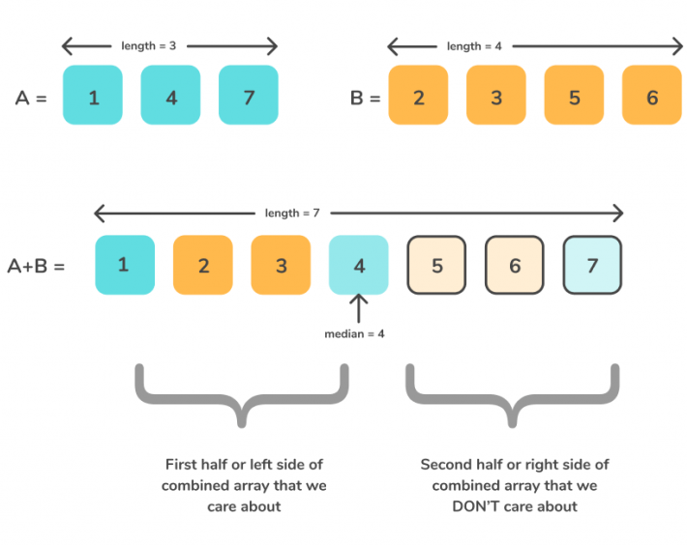
From the above diagram, it can be easily deduced that only the first half of the array is needed and the right half can be discarded.
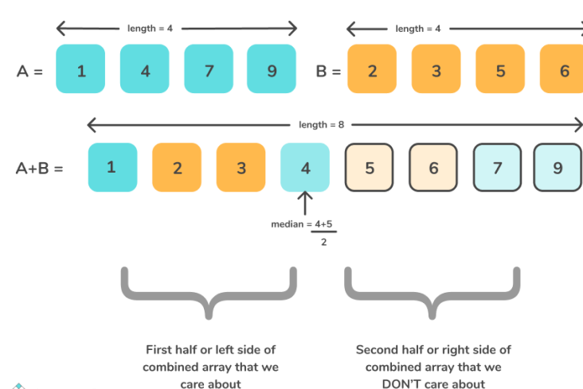

- Similarly, for an even length merged array, ignore the right half and only the left half contributes to our final answer.
- Therefore, the motive of our approach is to find which of the elements from both the array helps in contributing to the final answer. Therefore, the binary search comes to the rescue, as it can discard a part of the array every time, the elements don’t contribute to the median.
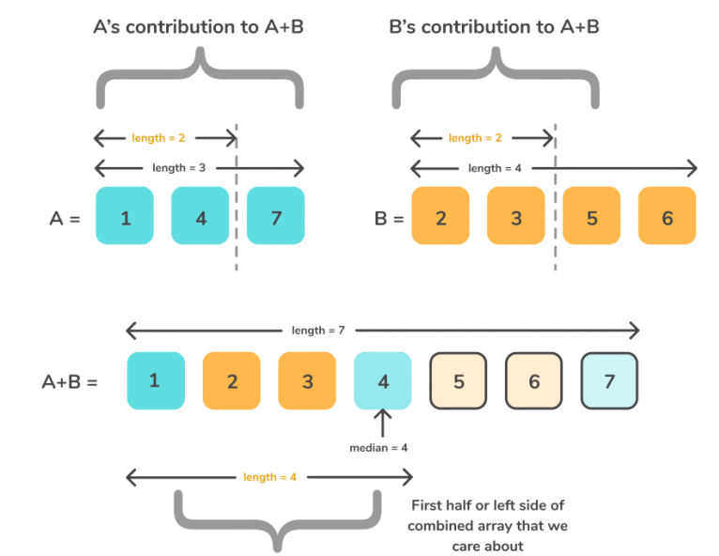
Algorithm
- The first array A is of size m, hence it can be split into m + 1 parts.
- The second array B is of size n, hence it can be split into n + 1 parts
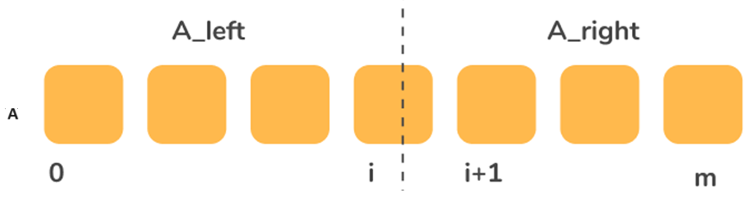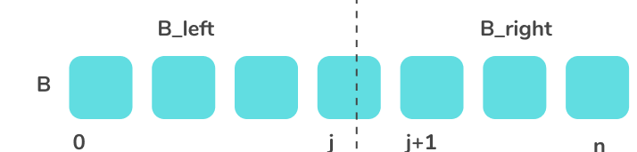
- As discussed earlier, we just need to find the elements contributing to the left half of the array.
  - Since, the arrays are already sorted, it can be deduced that A[i – 1] < A[i] and B[j – 1] < B[j].
  - Therefore, we just need to find the index i, such that A[i – 1] <= B[j] and B[j – 1] <= A[i].
- Consider mid = (n + m – 1) / 2 and check if this satisfies the above condition.
  - If A[i-1] <= B[j] and B[j-1]<=A[i] satisfies the condition, return the index i.
  - If A[i] <B[j – 1], increase the range towards the right. Hence update i= mid + 1.
  - Similarly, if A[i – 1] > B[j], decrease the range towards left. Hence update i= mid – 1.
Few corner cases to take care of :
- If the size of any of the arrays is 0, return the median of the non-zero sized array.
- If the size of smaller array is 1:
  - If the size of the larger array is also one, simply return the median as the mean of both the elements.
  - Else, if size of larger array is odd, adding the element from first array will result in size even, hence median will be affected if and only if, the element of the first array lies between , M / 2th and M/2 + 1th element of B[].
  - Similarly, if the size of the larger array is even, check for the element of the smaller array, M/2th element and M / 2 + 1 th element.
  - If the size of smaller array is 2, if a larger array has an odd number of elements, the median can be either the middle element or the median of elements of smaller array and M/2 -1th element or minimum of the second element of A[] and M/2+ 1 th array.

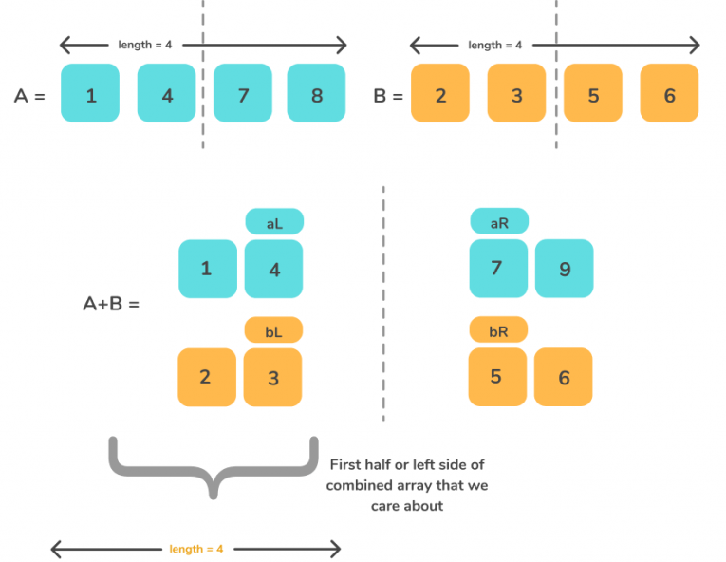

Java program for MedianOfTwoSortedArray(Binary search approach)
MedianSortedArrays.java
/*
In a school, 5th standard is having 2 sections called Rose and Lotus.
Section Rose contains 'm' students and Lotus contains 'n' students.
Each section students scored marks in Mathematics exam.
Teacher maintained a record of marks in ascending order of each section.
Now your task is to find out the median of the marks of 2 sections together.

Note: The overall run time complexity should be O(log (m+n)) .

Example 1:
Sample Input=
4
6
32 45 70 95
40 50 59 67 73 84

Sample Output=
63.0 //median

Example 2:
Sample Input=
5
6
10 20 30 40 50
35 44 60 70 80 90

Sample Output=
44

Input 3:
4
6
3 6 8 10
14 17 20 33 44 55

Output:
15.5

Input 4:
3
5
50 60 80
7 10 20 30 40

Output:
35

Input 4:
5
3
7 10 20 30 40
50 60 80

Output:
35

*/

/*
Time complexity: O(log(min(x,y))
Space complexity: O(1)
*/

import java.util.*;

class MedianSortedArrays {
public double findMedianSortedArrays(int[] arr1, int[] arr2)
{
int lenA = arr1.length;
int lenB = arr2.length;
// If arr1 has more elements, then call findMedianSortedArrays with reversed parameters
if(lenA>lenB)
return findMedianSortedArrays(arr2, arr1);

int low = 0;
int high = lenA;

System.out.println("arr1 length " + arr1.length + " arr2 length " + arr2.length);

while(low <= high)
{
int midA = (low + high)/2;
int midB = (lenA + lenB + 1)/2 - midA;

System.out.println("low " + low + " high " + high);
System.out.println("midA " + midA + " midB " + midB);

// Edge cases:
// If midA = 0, it means nothing is there on left side. Use -INF for
maxLeftX
// If midA = length of input, it means nothing is there on right side.
Use +INF for minRightX
// Do the same for 2nd array (midA, midB)

int maxLA = (midA == 0) ?Integer.MIN_VALUE : arr1[midA - 1];
int minRA = (midA == lenA) ?Integer.MAX_VALUE : arr1[midA];

int maxLB = (midB == 0) ?Integer.MIN_VALUE : arr2[midB - 1];
int minRB = (midB == lenB) ?Integer.MAX_VALUE : arr2[midB];

System.out.println("maxLA " + maxLA + " minRA " + minRA);
System.out.println("maxLB " + maxLB + " minRB " + minRB);

if(maxLA<= minRB&&maxLB<= minRA)
{
System.out.println("Found the median");
// Array partitioning is @ correct place
// Now get max of left elements and min of right elements to
get the median
// in case of even length combined array size
// or
// get max of left for odd length combined array size

if((lenA + lenB) %2 == 0)
{
return ((double)(Math.max(maxLA, maxLB) +
Math.min(minRA, minRB)))/2;
}
else
{
return (double)Math.max(maxLA, maxLB);
}
}
else if(maxLA>minRB) // We are too far on right side for midA.
Need to move left
{
high = midA - 1;
}
else if(minRA<maxLB) // We are too far on left side for midA.
Need to move right
{
low = midA + 1;
}
}
return -1;
}

public static void main(String[] args) {
Scanner sc=new Scanner(System.in);
int m=sc.nextInt();
int n=sc.nextInt();

int[] A= new int[m];
int[] B=new int[n];

for(int i=0;i<m;i++)
A[i]= sc.nextInt();

for(int i=0;i<n;i++)
B[i]= sc.nextInt();

System.out.println( newMedianSortedArrays().findMedianSortedArrays(A,B) );
}
}

- Find the fixed point in a given array.

- Given an array of n distinct integers sorted in ascending order, write a function that returns a Fixed Point in the array, if there is any Fixed-Point present in array, else returns -1.
- Fixed Point in an array is an index i such that arr[i] is equal to i. Note that integers in array can be negative. If there are multiple fixed points return the smallest index.

No duplicates are allowed

Example 1:
Input: [-10,-5,0,3,7]
Output: 3
Explanation:
For the given array, A[0] = -10, A[1] = -5, A[2] = 0, A[3] = 3, thus the output is 3.

Example 2:
Input: [0,2,5,8,17]
Output: 0
Explanation:
A[0] = 0, thus the output is 0.

Example 3:
Input: [-10,-5,3,4,7,9]
Output: -1
Explanation:
There is no such i that A[i] = i, thus the output is -1.

Note:
1 <= A.length< 10^4
-10^9 <= A[i] <= 10^9

Algorithm
The basic idea of ​​binary search is to divide n elements into two roughly equal parts, and compare a[n/2] with x.
- If x=a[n/2], then find x and the algorithm continues till a smaller x is found;
- if x<a[n/2], as long as you continue to search for x in the left half of array a,
- if x>a[n/2], then as long as you search for x in the right half of array a.
Java program for Find the Fixed point in an array: Fixedpoint.java
import java.util.*;
class FixedPoint
{
public int fixedPoint(int[] nums)
{
int lft = 0, rt = nums.length - 1;
while (lft< rt)
{
int mid = (lft + rt) / 2;
if (nums[mid] >= mid)
rt = mid;
else
lft = mid + 1;
}
return nums[lft] == lft ?lft : -1;
}

public static void main(String args[])
{
Scanner sc=new Scanner(System.in);
int n=sc.nextInt();
int arr[]=new int[n];
for(int i=0;i<n;i++)
arr[i]=sc.nextInt();
Arrays.sort(arr);
// Printing the array after sorting
System.out.println("sorted array[]:"+ Arrays.toString(arr));
System.out.println(new FixedPoint().fixedPoint(arr));
}
}

- Find Smallest Common Element in All Rows.

Given a matrix where every row is sorted in increasing order. Write a function that finds and returns the smallest common element in all rows. If there is no common element, then returns -1.
Example-1:
Input:mat [4][5] ={ {1, 2, 3, 4, 5},
{2, 4, 5, 8, 10},
{3, 5, 7, 9, 11},
{1, 3, 5, 7, 9}};
Output: 5
Example-2:
Input:mat [4][5]={{1, 2, 3, 4, 8},
{1, 4, 7, 8, 11},
{1, 8, 9. 12, 15},
{1, 5, 8, 20, 21}
}
Output: 1 8 or 8 1
8 and 1 are present in all rows.
Time complexity:

- A O(m*n*n) simple solution is to take every element of first row and search it in all other rows, till we find a common element.
- Time complexity of this solution is O(m*n*n) where m is number of rows and n is number of columns in given matrix.
- This can be improved to O(m*n*logn) if we use Binary Search instead oflinear search.

Java program for Find the Smallest Common Element:
SmallestCommonElement.java

import java.util.*;
class SmallestCommonElement
{
private static booleanbinarySearch(int[] arr, int low, int high, int target)
{
while(low <= high)
{
int mid = (low + high)/2;
if(arr[mid] == target)
return true;
else if(arr[mid] < target)
low = mid+1;
else
high = mid-1;
}
return false;
}
public static int smallestCommonElement(int[][] mat)
{
if(mat.length == 1)
return mat[0][0];
int lastEle = mat[0][mat[0].length -1];
// Get each element of array 1. Compare with each element of remaining array elements
OUTER: for(int ele :mat[0])
{
int count = 1;
for(int i = 1; i<mat.length; i++)
{
// If the last element of first row is lesser than the first
// element of any other row there is no common element
if(lastEle< mat[i][0])
break OUTER;
if(binarySearch(mat[i], 0, mat[i].length-1, ele))
count++;
else
break;
}

if(count == mat.length)
return ele;
}
return -1;
}

public static void main(String[] args)
{
Scanner sc=new Scanner(System.in);
int m=sc.nextInt();
int n=sc.nextInt();
int[][] arr = new int[m][n];
for(int i=0;i<m;i++)
for(int j=0;j<n;j++)
arr[i][j] = sc.nextInt();
System.out.println(smallestCommonElement(arr));
}
}

- Longest Common Prefix

Problem Statement:
- Given the array of strings S[], you need to find the longest string S which is the prefix of ALL the strings in the array.
- Longest common prefix (LCP) for a pair of strings S1 and S2 is the longest string S which is the prefix of both S1 and S2.
- For Example: longest common prefix of “abcdefgh” and “abcefgh” is “abc”.

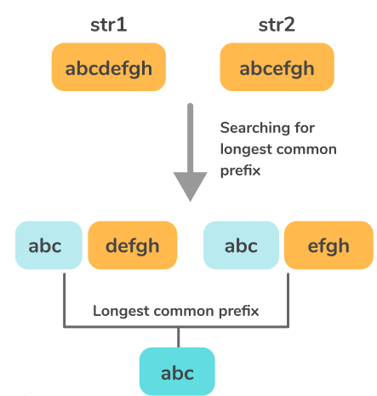

Examples:
Input: S[] = {“abcdefgh”, “abcefgh”}
Output: “abc”
Explanation: Explained in the image description above
Input: S[] = {“abcdefgh”, “aefghijk”, “abcefgh”}
Output: “a”

Binary Search Approach

Algorithm:
- Consider the string with the smallest length. Let the length be L.
- Consider a variable low = 0 and high= L – 1.
- Perform binary search:
  - Divide the string into two halves, i.e. low – mid and mid + 1 to high.
  - Compare the substring upto the mid of this smallest string to every other character of the remaining strings at that index.
  - If the substring from 0 to mid – 1 is common among all the substrings, update low with mid + 1, else update high with mid – 1
  - If low == high, terminate the algorithm and return the substring from 0 to mid.

Java program for LongestCommonPrefix using Binary search approach
LCP_BS.java
/*
Time complexity: O(NM log M)
N = Number of strings
M = Length of the longest string

Space complexity:
O(M)
M = Length of the longest string
*/
import java.util.*;
class LCP_BS
{
// A Function to find the string having the minimum length
static int findMinLength(String arr[], int n)
{
int min = Integer.MAX_VALUE;
for (int i = 0; i< n; i++)
{
if (arr[i].length() < min)
{
min = arr[i].length();
}
}
return min;
}

public static String longestCommonPrefix(String[] strs, int n)
{
if (strs == null || strs.length == 0) return "";

int index = findMinLength(strs, n);
String prefix;
int prefixLen = -1;

int low = 0, high = index;
while (low <= high)
{
int mid = (low + high) / 2;
if(isCommon(strs, mid))
{
low = mid+1;
prefixLen = mid;
}
else
{
high = mid-1;
}
}
prefix = strs[0].substring(0, prefixLen);
return prefix.toString();
}

public static booleanisCommon(String[] str, int len)
{
String pre = str[0].substring(0, len);
for(int i = 1; i<str.length; i++)
{
if(!str[i].startsWith(pre))
{
return false;
}
}
return true;
}

public static void main(String args[])
{
// hello hell her he
// genesis general generic
Scanner sc= new Scanner(System.in);
String[] words = sc.nextLine().split(" ");
System.out.println(longestCommonPrefix(words, words.length));
}
}

input:
flowerflowflight
output:fl

- Koko Eating Bananas:

- In the problem ”Koko Eating Bananas” we are given an array of size n which contains the number of bananas in each pile. In one hour Koko can eat at most K bananas. If the pile contains less than K bananas in that case if Koko finishes all bananas of that pile then she cannot start eating bananas from another pile in the same hour.
- Koko wants to eat all bananas within H hours. We are supposed to find the minimum value of K.
Input:
piles = [30,11,23,4,20], H = 6

output:
23
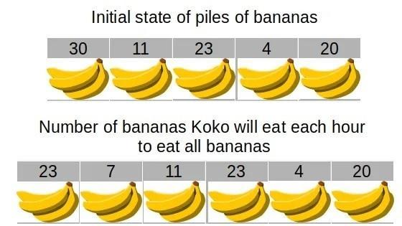
Koko will eat bananas in this way to eat all bananas in 6 hours:
First hour: 23
Second hour: 7
Third hour: 11
Fourth hour: 23

Approach for Koko Eating Bananas
The first and the most important thing to solve this problem is to bring out observations. Here are a few observations for our search interval:
- Koko must eat at least one banana per hour. So, this is the minimum value of K. let’s name it as Start
- We can limit the maximum number of bananas Koko can eat in one hour to the maximum number of bananas in a pile out of all the piles. So, this is the maximum value of K. let’s name it as End.

Now we have our search interval. Suppose the size of the interval is Length and the number of piles is n. The naive approach could be to check for each value in the interval. if for that value of K Koko can eat all bananas in H hour successfully then pick the minimum of them. The time complexity for the naive approach will be Length*n in worst case.
We can improve the time complexity by using Binary Search in place of Linear Search.The time complexity using the Binary Search approach will be log(Length)*n.

Time complexity:
The time complexity of the above code is O(n*log(W)) because we are performing a binary search between one and W this takes logW time and for each value, in the binary search, we are traversing the piles array. So, the piles array is traversed logW times it makes the time complexity n*logW. Here n and W are the numbers of piles and the maximum number of bananas in a pile.

Space complexity:
The space complexity of the above code is O(1) because we are using only a variable to store the answer.

Java program for Kokoeatingbananas: KokoEatingBananas_BS.java
import java.util.*;

public class KokoEatingBananas_BS
{

public static int calculateHrsSpent(int[] piles, int k)
{
int hoursSpent = 0;
// Iterate over the piles and calculate hoursSpent.
// We increase the hoursSpent by ceil(pile / k)
for (int pile : piles) {
hoursSpent += Math.ceil((double) pile / k);
}
return hoursSpent;

}
public static int minEatingSpeed(int[] piles, int hrs)
{
// Initalize the left and right boundaries
int left = 1, right = 1;
for (int pile : piles) {
right = Math.max(right, pile);
}
System.out.println("left " + left + " right " + right);

while (left < right)
{
// Get the middle index between left and right boundary indexes.
// hourSpent stands for the total hour Koko spends.
int middle = (left + right) / 2;
int hoursSpent = 0;

System.out.println("left " + left + " right " + right + " middle " + middle);

hoursSpent = calculateHrsSpent(piles, middle);

// Check if middle is a workable speed, and cut the search space by half.
if (hoursSpent<= hrs) {
right = middle;
} else {
left = middle + 1;
}
}

// Once the left and right boundaries coincide, we find the target value,
// that is, the minimum workable eating speed.
return right;
}

public static void main(String args[])
{
Scanner sc = new Scanner(System.in);
String [] str = sc.nextLine().split(" ");

int[] boxes = new int[str.length];
for (int i = 0; i<str.length; i++) {
boxes[i] = Integer.valueOf(str[i]);
}

int hours = sc.nextInt();
System.out.println(minEatingSpeed(boxes, hours));
}
}

GREEDY METHOD

A greedy algorithm is an optimization technique that makes the locally optimal choice at each step, aiming to find a global optimum solution.
Optimization problem is a problem which requires minimum results or maximum results.
Greedy method is used for solving optimization problem.
Greedy method says that, our problem should be solved in stages.
In each stage we consider one input for given problem. If that input is feasible, then that will be included in the solution.By including all those feasible inputs, we will get a local optimal solution.
At each step, it picks a locally optimal choice in anticipation of finding a globally optimal solution. As a result, the greedy algorithm sometimes traps in the local optima and thus could not provide a globally optimal solution (find the minimum number of coins for making the change of a given amount of money). Greedy approach never reconsiders the choices taken previously.

The algorithm proceeds as follows:
- Make a choice – Pick the best available option based on a specific criterion.
- Move to the next step – Update the state and repeat the process.
- Check constraints – Ensure the choice satisfies problem constraints.
- Repeat – Continue until a complete solution is formed or no further progress is possible.
Greedy algorithms are fast and efficient, often running in linear or logarithmic time, but they do not always guarantee the globally optimal solution

1. Fractional Knapsack Problem
Given the weights and profits of N items, in the form of {profit, weight} put these items in a knapsack of capacity W to get the maximum total profit in the knapsack.
In Fractional Knapsack, we can break items for maximizing the total value of the knapsack.
The basic idea of the greedy approach is to calculate the ratio profit/weight for each item and sort the item on the basis of this ratio.
Then take the item with the highest ratio and add them as much as we can (can be the whole element or a fraction of it).
This will always give the maximum profit because, in each step it adds an element such that this is the maximum possible profit for that much weight.
Algorithm:
- Input profits and weights of N items
- Calculate the ratio (profit/weight) for each item.
- Sort all the items in decreasing order of the ratio.
- Initialize res = 0, curr_cap = given_cap.
[Here, curr_cap is current capacity, given_cap is given capacity]
- Do the following for every item “I” in the sorted order:
  - If the weight of the current item is less than or equal to the remaining capacity then add the value of that item into the result
  - Else add the current item as much as we can and break out of the loop.
- Return res.

Example:
Consider the example: arr[] = [ [100, 20], [60, 10], [120, 30] ], W = 50.
The sorted array will be {{60, 10}, {100, 20}, {120, 30}}.
[Initially sort the array based on the profit/weight ratio.]
Iteration:
- For i = 0, weight = 10 which is less than W. So, add this element in the knapsack.
profit = 60 and remaining W = 50 – 10 = 40.
- For i = 1, weight = 20 which is less than W. So, add this element too.
profit = 60 + 100 = 160 and remaining W = 40 – 20 = 20.
- For i = 2, weight = 30 is greater than W. So, add 20/30 fraction = 2/3 fraction of the element. Therefore profit = 2/3 * 120 + 160 = 80 + 160 = 240 and remaining W becomes 0.

Time Complexity: O(N * logN)
Auxiliary Space: O(N)

// Java program to solve fractional Knapsack Problem
import java.util.*;

// item value class
class ItemValue implements Comparable<ItemValue>{
int value, weight;
ItemValue(int value, int weight){
this.value = value;
this.weight = weight;
}
public int getValue(){
return value;
}
public int getWeight(){
return weight;
}
@Override
public int compareTo(ItemValue v1){
double ratio = (double)this.value/this.weight;
double ratio2 = (double)v1.value/v1.weight;
return Double.compare(ratio2, ratio);
}
@Override
public String toString(){
String s = getValue() + "," + getWeight();
return s;
}
}

public class Knapsack {
// function to get maximum value
private static double getMaxValue(ItemValue[] arr, int capacity)
{
printItems(arr);

// sorting items by value/weight ratio;
Arrays.sort(arr);

System.out.println("After sorting");
printItems(arr);

double totalValue = 0d;
for (ItemValueitem :arr)
{
if (capacity - item.getWeight() >= 0)
{
// this item can be picked whole
capacity -= item.getWeight();
totalValue += item.getValue();
}
else {
// item itemcant be picked whole
totalValue += item.getValue() * ((double) capacity /
item.getWeight());
break;
}
}
return totalValue;
}

static void printItems(ItemValue[] arr)
{
for(int i = 0; i<arr.length; i++)
{
System.out.println("[" + arr[i] + "]");
}
}

public static void main(String[] args)
{
ItemValue[] arr = { newItemValue(100, 20),
new ItemValue(60, 10),
new ItemValue(120, 30)};
int capacity = 50;
double maxValue = getMaxValue(arr, capacity);
// Function call
System.out.println("Maximum value we can obtain = "+ maxValue);
}
}

2. 0/1 Knapsack Problem
- Given the weights and profits of N items, in the form of {profit, weight} put these items in a knapsack of capacity W to get the maximum total profit in the knapsack.
- The constraint here is we can either put an item completely into the bag or cannot put it at all
[It is not possible to put a part of an item into the bag]
- Its either the item is added to the knapsack or not. That is why, this method is known as the 0-1
- Hence, in case of 0-1 Knapsack, the value of x_{i} can be either 0 or 1, where other constraints remain the same.
Example:
Let us consider that the capacity of the knapsack is W = 8 and the items are as shown in the following table.
Item | A | B | C | D
Profit | 2 | 4 | 7 | 10
Weight | 1 | 3 | 5 | 7

Note: This solution we will discuss when we cover Dynamic Programming
Following are differences betweenthe 0/1 knapsack problem and the Fractional Knapsack problem

Sr. No | 0/1 knapsack problem | Fractional knapsack problem
1. | The 0/1 knapsack problem is solved using dynamic programming approach. | Fractional knapsack problem is solved using a greedy approach.
2. | The 0/1 knapsack problem has not an optimal structure. | The fractional knapsack problem has an optimal structure.
3. | In the 0/1 knapsack problem, we are not allowed to break items. | Fractional knapsack problem, we can break items for maximizing the total value of the knapsack.
4. | 0/1 knapsack problem, finds a most valuable subset item with a total value less than equal to weight. | In the fractional knapsack problem, finds a most valuable subset item with a total value equal to the weight.
5. | In the 0/1 knapsack problem we can take objects in an integer value. | In the fractional knapsack problem, we can take objects in fractions in floating points.

A graph can be represented as a collection of vertices with edges joiningthem. The most popular types of graphs:
- Undirected Graph:An undirected graph is one where the edges do not indicate in the same direction, making it bidirectional instead of unidirectional. It’s also feasible to consider it as a graph with V vertices and E edges, eachuniting two separate vertices.
- Connected Graph:A connected graph is one when there is invariably a path from one vertex to another. Also, we can say that a graph is connected if we can go to any vertex from any different vertex by pursuing edges in either direction.
- DirectedGraph:A graphisconsideredadirectedgraphifall theedgespresentbetweenanynodesor verticeshave a defined direction.

Single Source Shortest Paths
We have a graph G (V, E).
We assume one vertex as a source vertex.
We must find the shortest path from source vertex to all the remaining vertices of the graph.

Dijkstra’s Algorithm:

The algorithm maintains a set of visited vertices and a set of unvisited vertices. It starts at the source vertex and iteratively selects the unvisited vertex with the smallest tentative distance from the source. It then visits the neighbors of this vertex and updates their tentative distances if a shorter path is found. This process continues until the destination vertex is reached, or all reachable vertices have been visited.

Can Dijkstra’s Algorithm work on both Directed and Undirected graphs?

Yes, Dijkstra’s algorithm can work on both directed graphs and undirected graphs as this algorithm is designed to work on any type of graph as long as it meets the requirements of having non-negative edge weights and being connected.

- In a directed graph, each edge has a direction, indicating the direction of travel between the vertices connected by the edge. In this case, the algorithm follows the direction of the edges when searching for the shortest path.

- In an undirected graph, the edges have no direction, and the algorithm can traverse both forward and backward along the edges when searching for the shortest path.

Algorithm for Dijkstra’s Algorithm:

- Mark the source node with a current distance of 0 and the rest with infinity.
- Set the non-visited node with the smallest current distance as the current node.
- For each neighbor, N of the current node adds the current distance of the adjacent node with the weight of the edge connecting 0->1. If it is smaller than the current distance of Node, set it as the new current distance of N.
- Mark the current node 1 as visited.
- Go to step 2 if there are any nodes unvisited.

Example:
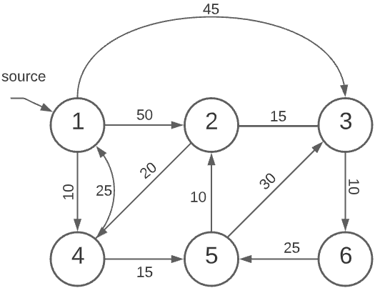

We assume vertex 1 as the source vertex.
We must find shortest paths from 1 to remaining vertices.

In the first step we identify the vertex which is of shortest distance from 1 i.e.,1 – 4 cost is 10

Now we identify the vertices that can be reached from 4 i.e., 4 – 5 cost is 15
Now 1 – 5direct edge cost is ∞ because there is no edge between 1 and 5 but the edge cost of 1 – 4and 4 – 5is 10+15=25.
Therefore, edge cost of 1 – 5 is 25.

Now we identify the vertices that can be reached from 5 i.e., 5 – 2and 5 – 3

Now 1 – 2direct edge cost 50 but edge cost between 1 – 5and 5 – 2is 25+10=35
Therefore, edge cost of 1 – 2 is 35

Now 1 – 3direct edge cost is 45 but edge cost between 1 – 5and 5 – 3is 25+30=55
Therefore, edge cost of 1 – 3 is 45

Now identify vertices that can be reached from 2 is 3
Now direct edge cost between 1 – 3is 45 but edge cost between 1 – 2and 2 – 3is 35+15=50
Therefore, edge cost of 1 – 3is 45

Now we identify the vertices that can be reached from 3 i.e., 3 – 6.
Now 1 – 6 direct edge cost is ∞ but edge cost of 1 – 3and 3 – 6is 45 + 10 = 55
Therefore, edge cost of 1 – 6 is 55

Solution:
1 – 4=> 10, 1 – 5=> 25,1 – 2=> 35, 1 – 3=> 45, 1 – 6=>55

/* A Java program for Dijkstra's single source shortest path algorithm.
The program is for adjacency matrix representation of the graph */

import java.util.*;
import java.lang.*;
import java.io.*;

class ShortestPath
{
/* A utility function to find the vertex with minimum distance value, from the set of vertices not yet included in shortest path tree */
static final int V;
int minDistance(int dist[], Boolean visited[])
{
// Initialize min value
int min = Integer.MAX_VALUE, min_index = -1;
for (int v = 0; v < V; v++)
{
if (visited[v] == false &&dist[v] <= min)
{
min = dist[v];
min_index = v;
}
}
return min_index;
}

// A utility function to print the constructed distance array
// Print the constructed distance array
void printSolution(int dist[], int src)
{
System.out.println("Vertex \t Distance from Source " + src);
for (int i = 0; i< V; i++)
System.out.println(i + " \t " + dist[i]);
}

/* Function that implements Dijkstra's single source shortest path algorithm for a graph represented using adjacency matrix representation*/
void dijkstra(int graph[][], int src)
{
int dist[] = new int[V]; // The output array. dist[i] will hold
/* the shortest distance from src to i.
sptSet[i] will true if vertex i is included in shortest path tree or shortest distancefrom src to i is finalized */
Boolean sptSet[] = new Boolean[V];

// Initialize all distances as INFINITE and stpSet[] as false
for (int i = 0; i< V; i++)
{
dist[i] = Integer.MAX_VALUE;
sptSet[i] = false;
}

// Distance of source vertex from itself is always 0
dist[src] = 0;

// Find shortest path for all vertices
for (int count = 0; count < V - 1; count++)
{
/* Pick the minimum distance vertex from the set of vertices not yet processed. u is always equal to src in first iteration.*/
int u = minDistance(dist, sptSet);

// Mark the picked vertex as processed
sptSet[u] = true;

// Update dist value of the adjacent vertices of the picked vertex.
for (int v = 0; v < V; v++)
{
/* Update dist[v] only if is not in sptSet, there is an edge from u to v, and total weight of path from src to v through u is smaller than current value of dist[v] */
int weight = graph[u][v];

if (!visited[v] &&weight != 0 &&
dist[u] != Integer.MAX_VALUE&&dist[u] + weight <dist[v])
{
dist[v] = dist[u] + weight;
System.out.println(Arrays.toString(dist));
} }
}
// print the constructed distance array
printSolution(dist, src);
}

public static void main(String[] args)
{
Scanner sc = new Scanner(System.in);
int r = sc.nextInt();
V = r;
int[][] graph = new int[r][r];
for(int i=0;i<r;i++){
for(int j=0;j<r;j++)
graph[i][j]=sc.nextInt();
}
ShortestPath t = new ShortestPath();
int srcVertex = sc.nextInt();
t.dijkstra(graph, srcVertex);
}
}

Time Complexity:

- Using a simple implementation with an array: O(V²), where V is the number of vertices.
- Using a priority queue (min-heap):O((V+E)logV),whereV is the number of vertices and E is the number of edges.

Minimum Cost Spanning Trees
A spanning tree is a subset of Graph G, such that all the vertices are connected using minimum possible number of edges. Hence, a spanning tree does not have cycles and a graph may have more than one spanning tree.
Let G=(V, E) be an undirected connected graph. A subgraph t=(v,E’) of G is a spanning tree of G if t is a tree. Eg. Graph
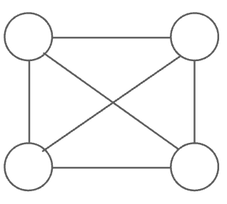
Spanning trees are
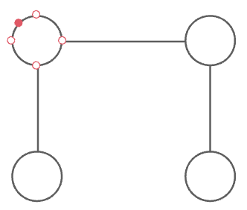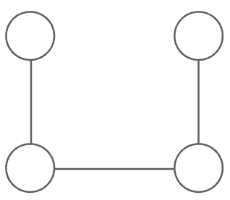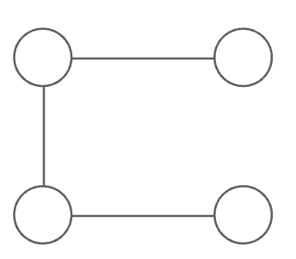
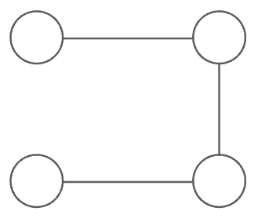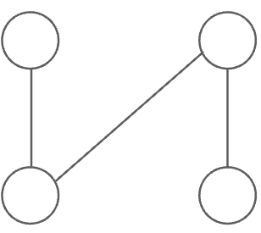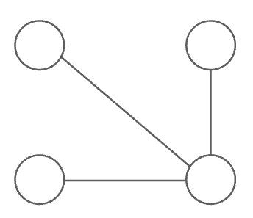
The spanning tree with minimum edge cost sum is minimum cost spanning tree.
Since the identification of a minimum cost spanning tree involves the selection of a subset of edge the problem fits the subset paradigm.

Properties of a Spanning Tree:

- A Spanning tree does not exist for a disconnected graph.

- For a connected graph having N vertices then the number of edges in the spanning tree for that graph will be N-1.

- A Spanning tree does not have any cycle.

- We can construct a spanning tree for a complete graph by removing E-N+1 edges, where E is the number of Edges and N is the number of vertices.

- Cayley’s Formula: It states that the number of spanning trees in a complete graph with N vertices is N^{N-2}
For example: N=4, then maximum number of spanning tree possible =4^{4-2} = 16

Real-WorldApplicationofMinimumSpanningTree
- The building or connecting of roads among cities or villages at a minimal cost.
- Network service providers for finding the minimal cost to provide service to every user.
- Cluster Analysis of data sets
- Protocols to avoid network cycles
- Maximum bottleneck paths
- Areal-time face tracking algorithm
- Dithering algorithms
- Prime Factorial

There are 2 methods to find minimum cost spamming trees
- Prim’s algorithm
- Kruskal’s algorithm
Prim’s algorithm :- builds the tree edge by edge, the next edge to include is chosen according to some optimization criteria. The criterion is to choose an edge that results in a minimum increase in the sum of costs of edges so far included.

Follow the given steps to utilize the Prim’s Algorithm for finding MST of a graph:

- Create a set mstSet that keeps track of vertices already included in MST.

- Assign a weight value to all vertices in the input graph. Initialize all weight values as INFINITE. Assign the weight value as 0 for the first vertex so that it is picked first.

- While mstSet doesn’t include all vertices
  - Pick a vertex u that is not there in mstSet and has a minimum weight value.
  - Include u in the mstSet.
  - Update the weight value of all adjacent vertices of u. To update the weight values, iterate through all adjacent vertices.
    - For every adjacent vertex v, if the weight of edge u-v is less than the previous weight value of v, update the weight value as the weight of u-v.

PROGRAM MST.java

// A Java program for Prim's Minimum Spanning Tree (MST)
// algorithm. The program is for adjacency matrix representation of the graph

import java.io.*;
import java.lang.*;
import java.util.*;

class MST {

// Number of vertices in the graph
private static final int V = 5;

// A utility function to find the vertex with minimum weight value,
// from the set of vertices not yet included in MST
int minWeight(int weight[], Boolean mstSet[])
{
// Initialize min value
int min = Integer.MAX_VALUE, min_index = -1;

System.out.println("weights " + Arrays.toString(weight));
System.out.println("mstSet " + Arrays.toString(mstSet));

for (int v = 0; v < V; v++)
{
if (mstSet[v] == false && weight[v] < min) {
min = weight[v];
min_index = v;
}
}
return min_index;
}

// A utility function to print the constructed MST stored in parent[]
void printMST(int parent[], int graph[][])
{
System.out.println("Edge \tWeight");
for (int i = 1; i< V; i++)
System.out.println(parent[i] + " - " + i + "\t"
+ graph[i][parent[i]]);
}

// Function to construct and print MST for a graph
// represented using adjacency matrix representation
void primMST(int graph[][])
{
// Array to store constructed MST
int parent[] = new int[V];

// weight values used to pick minimum weight edge
int weight[] = new int[V];

// To represent set of vertices included in MST
Boolean mstSet[] = new Boolean[V];

// Initialize all weights as INFINITE
for (int i = 0; i< V; i++) {
weight[i] = Integer.MAX_VALUE;
mstSet[i] = false;
}

// Always include first 1st vertex in MST. Make weight 0 so that this vertex is
// picked as first vertex
weight[0] = 0;

// First node is always root of MST
parent[0] = -1;

// The MST will have V vertices
for (int count = 0; count < V - 1; count++) {

// Pick the minimum weight vertex from the set of
// vertices not yet included in MST
int u = minWeight(weight, mstSet);

System.out.println("min vertex " + u);

// Add the picked vertex to the MST Set
mstSet[u] = true;

// Update weight value and parent index of the adjacent vertices of the
picked vertex.
// Consider only those vertices which are not yet included in MST
for (int v = 0; v < V; v++)
{
// graph[u][v] is non zero only for adjacent vertices of matrix
// mstSet[v] is false for vertices not yet included in MST
// Update the weight only if graph[u][v] is smaller than weight[v]
if (graph[u][v] != 0 &&mstSet[v] == false && graph[u][v] <
weight[v])
{
parent[v] = u;
weight[v] = graph[u][v];
}
}
System.out.println("Parent " + Arrays.toString(parent) );
}

// Print the constructed MST
printMST(parent, graph);
}

public static void main(String[] args)
{
MST t = new MST();
int graph[][] = new int[][] { { 0, 2, 0, 6, 0 },
{ 2, 0, 3, 8, 5 },
{ 0, 3, 0, 0, 7 },
{ 6, 8, 0, 0, 9 },
{ 0, 5, 7, 9, 0 } };

// Print the solution
t.primMST(graph);
}
}

Kruskal’s Algorithm:
This mechanism selects the set of edges considering the next minimum cost edge every time, in such a way that no cycle occurs and by the time n-1 edges are considered a minimum cbost spanning tree is generated. The set of edges considered may not be a tree all the time.
The generalized Kruskal’s algorithm is a follows
1) Sort edges by ascending edge weight
2) Walk through the sorted edges and look at the two nodes the edge belongs to. If the nodes are already unified we don’t include this edge, otherwise we include it and unify the nodes
3) The algorithm terminates when every edge has been processed or all the vertices have been unified
Program for Kruskal's algorithm to find Minimum Spanning Tree of a given connected, undirected and weighted graph

import java.util.*;
class Graph
{
// A class to represent a graph edge
class Edge implements Comparable<Edge>
{
int src, dest, weight;

// Comparator function used for sorting edges based on their weight
public int compareTo(Edge compareEdge)
{
return this.weight - compareEdge.weight;
}
public String toString()
{
return src + " " + dest + " " + weight;
}
};

// A class to represent a subset for union-find
class subset
{
int parent, rank;
};

int V, E; // V-> no. of vertices & E->no.of edges
Edge edge[]; // collection of all edges

// Creates a graph with V vertices and E edges
Graph(int v, int e)
{
V = v;
E = e;
edge = new Edge[E];
for (int i = 0; i< e; ++i)
edge[i] = new Edge();
}

// A utility function to find set of an element i (uses path compression technique)
int find(subset subsets[], int i)
{
// find root and make root as parent of i (path compression)
if (subsets[i].parent !=i)
subsets[i].parent = find(subsets, subsets[i].parent);

return subsets[i].parent;
}

// A function that does union of two sets of x and y (uses union by rank)
void Union(subset subsets[], int x, int y)
{
int xroot = find(subsets, x);
int yroot = find(subsets, y);

// Attach smaller rank tree under root of high rank tree (Union by Rank)
if (subsets[xroot].rank < subsets[yroot].rank)
subsets[xroot].parent = yroot;
else if (subsets[xroot].rank> subsets[yroot].rank)
subsets[yroot].parent = xroot;
// If ranks are same, then make one as root and increment its rank by one
else {
subsets[yroot].parent = xroot;
subsets[xroot].rank++;
}
}

void KruskalMST()
{
// This will store the resultant MST
Edge result[] = new Edge[V];

// An index variable, used for result[]
int e = 0;

// An index variable, used for sorted edges
int i = 0;
for (i = 0; i< V; ++i)
result[i] = new Edge();

/* Step 1: Sort all the edges in non-decreasing order of their weight.
If we are not allowed to change the given graph,
we can create a copy of array of edges */
Arrays.sort(edge);

// Allocate memory for creating V subsets
subset subsets[] = new subset[V];
for (i = 0; i< V; ++i)
subsets[i] = new subset();

// Create V subsets with single elements
for (int v = 0; v < V; ++v)
{
subsets[v].parent = v;
subsets[v].rank = 0;
}

i = 0; // Index used to pick next edge

// Number of edges to be taken is equal to V-1
while (e < V - 1)
{
// Step 2: Pick the smallest edge. And increment the index for next iteration
Edge next_edge = edge[i++];

int x = find(subsets, next_edge.src);
int y = find(subsets, next_edge.dest);

/* If including this edge doesn't cause cycle, include it in result and increment the index of result for next edge*/
if (x != y)
{
result[e++] = next_edge;
Union(subsets, x, y);
}
// Else discard the next_edge
}

// print the contents of result[] to display the built MST
int minimumCost = 0;
for (i = 0; i< e; ++i)
{
minimumCost += result[i].weight;
}
}

public static void main(String[] args)
{
Scanner sc=new Scanner(System.in);
int V = sc.nextInt();
int E = sc.nextInt();

Graph graph = new Graph(V, E);
for(int i = 0; i< E; i++)
{
graph.edge[i].src = sc.nextInt();
graph.edge[i].dest = sc.nextInt();
graph.edge[i].weight = sc.nextInt();
}

graph.KruskalMST();
}
}

Feature | Prim’s Algorithm | Kruskal’s Algorithm
Approach | Grows MST by starting from one vertex and adding the smalles edge that connects the tree to a new vertex. | Builds MST by sorting all edges and picking the smallest edge that doesn’t form a cycle.
Graph Type | Works best with dense graphs (many edges). | Works best with sparse graphs (fewer edges).
Data Structures Used | Uses a priority queue (min-heap) for edge selection. | Uses a Disjoint Set Union (DSU/Union-Find) to check cycles.
Initial Step | Start from any vertex. | Sort all edges by weight first.
Time Complexity | O(ElogV) with min-heap. | O(ElogE) ≈ O(ElogV) due to sorting.
Nature | Vertex-based (adds vertices to the tree). | Edge-based (adds edges to the tree).
Cycle Check | Avoids cycles naturally (since it always connects to a new vertex). | Explicitly checks for cycles using Union-Find.
MST Shape | Always produces a connected tree as it grows. | May form multiple components (forests) first, which later merge into MST.

Prim’s grows a tree step by step from one vertex.

- Kruskal’s grows forests by adding edges in order of weight.

Minimum Product subset of an Array

Given an array a, we have to find the minimum product possible with the subset of elements present in the array. The minimum product can be a single element also.

Input :a[] = {-1, -1, -2, 4, 3}
Output : -24
Explanation : Minimum product will be ( -2 * -1 * -1 * 4 * 3 ) = -24

Input :a[] = {-1, 0}
Output : -1
Explanation : -1(single element) is minimum product possible

Input :a[] = {0, 0, 0}
Output : 0

Solution is as follows
- If there are even number of negative numbers and no zeros, the result is the product of all except the largest valued negative number.
- If there are an odd number of negative numbers and no zeros, the result is simply the product of all.
- If there are zeros and positive, no negative, the result is 0. The exceptional case is when there is no negative number and all other elements positive then our result should be the first minimum positive number.

import java.util.*;
class MinProductSubset
{
static int minProductSubset(int a[], int n)
{
if (n == 1)
return a[0];
int negmax = Integer.MIN_VALUE;
int posmin = Integer.MAX_VALUE;
int count_neg = 0, count_zero = 0;
int product = 1;
for (int i = 0; i< n; i++)
{
// if number is zero,count it but don’t multiply
if (a[i] == 0)
{
count_zero++;
continue;
}

// count the negative numbers and find the max negative number
if (a[i] < 0)
{
count_neg++;
negmax = Math.max(negmax, a[i]);
}
// find the minimum positive number
if (a[i] > 0 && a[i] <posmin)
posmin = a[i];
product *= a[i];
}
// if there are all zeroes or zero is present but no negative number is present
if (count_zero == n || (count_neg == 0 &&count_zero> 0))
return 0;
// If there are all positive
if (count_neg == 0)
return posmin;
// If there are even number except zero of negative numbers
if (count_neg % 2 == 0 &&count_neg != 0)
{
//Otherwise, result is product of all non-zeros divided by maximum valued negative.
product = product / negmax;
}
return product;
}

public static void main(String[] args)
{
Scanner sc=new Scanner(System.in);
String[] arr=sc.next().split(",");
int n=arr.length;
int a[] = new int[arr.length];

for(int i=0;i<arr.length;i++)
a[i]=Integer.parseInt(arr[i]);
System.out.println(minProductSubset(a, n));
}
}

Best Time To Buy and Sell Stock
Given an arrayprices[] of length N, representing the prices of the stocks on different days, the task is to find the maximum profit possible for buying and selling the stocks on different days using transactions where at most one transaction is allowed.
Input: prices[] = {7, 1, 5, 3, 6, 4]
Output: 5
Explanation:
The lowest price of the stock is on the 2nd day, i.e. price = 1. Starting from the 2nd day, the highest price of the stock is witnessed on the 5th day, i.e. price = 6.
Therefore, maximum possible profit = 6 – 1 = 5.

Input: prices[] = {7, 6, 4, 3, 1}
Output: 0
Explanation: Since the array is in decreasing order, no possible way exists to solve the problem.
This problem can be solved using the greedy approach. To maximize the profit, we have to minimize the buy cost and we have to sell it at maximum price.
Follow the steps below to implement the above idea:
- Declare a buy variable to store the buy cost and max_profit to store the maximum profit.
- Initialize the buy variable to the first element of the prices array.
- Iterate over the prices array and check if the current price is minimum or not.
  - If the current price is minimum then buy on this ith day.
  - If the current price is greater than the previous buy then make profit from it and maximize the max_profit.
- Finally, return the max_profit

import java.util.*;
class BuyAndSellStock
{
public int maxProfit(int prices[])
{
int minprice = Integer.MAX_VALUE;
int maxprofit = 0;
for (int i = 0; i<prices.length; i++)
{
if (prices[i] <minprice)
minprice = prices[i];
else if (prices[i] - minprice>maxprofit)
maxprofit = prices[i] - minprice;
}
return maxprofit;
}

public static void main(String args[])
{
Scanner sc=new Scanner(System.in);
int n=sc.nextInt();
int ar[]=new int[n];
for(int i=0;i<n;i++)
ar[i]=sc.nextInt();
System.out.println(new BuyAndSellStock().maxProfit(ar));
}
}

TypeII:Infinitetransactionsareallowed

Givenanarrayprice[]oflengthN,representingthepricesofthestocksondifferentdays, the ask is to find the maximum profit possible for buying and selling the stocks on different days using transactions where any number of transactions are allowed.

input:prices[]={7,1,5,3,6, 4}

Output:7

Explanation:
Purchaseon2ndday.Price=1. Sell on 3rd day. Price = 5.
Therefore, profit = 5 – 1 = 4. Purchaseon4thday.Price=3. Sell on 5th day. Price = 6.
Therefore,profit=4+(6–3)=7.

Input:prices={1,2,3,4,5}

Output:4
Explanation:
Purchaseon1stday.Price=1. Sell on 5th day. Price = 5.
Therefore,profit=5– 1=4.

JavaprogramforBestTimetoBuyandSellStockwithInfinitetransactions:

BuyAndSellStock_InfiniteTransactions.java

import java.util.*;
class BuyAndSellStock_InfiniteTransactions
{
public static void main(String [] args)
{
Scanner sc = new Scanner(System.in);
int n=sc.nextInt();
int arr[] = new int[n];
for(int i=0;i<n;i++){
arr[i]=sc.nextInt();
}
System.out.println(prof(arr,n));
}

public static int prof(int arr[] , int n)
{
int profit=0;
for(int i=0;i<n-1;i++)
{
if(arr[i]<arr[i+1])
{
profit+=(arr[i+1]-arr[i]);
}
}
return profit;
}
}

